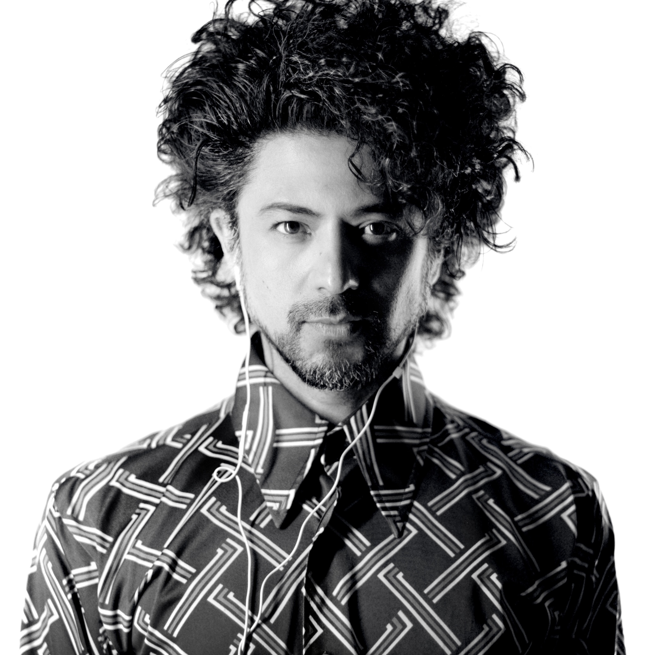
Lebenslauf
Arturo Fuentes | Komponist
Bildgasse 2, 6020 Innsbruck, Austria
+43.69916351607 | arturomusik@gmail.com
www.arturofuentes.com | www.londonhalleditions.com

Februar 2023

Arturo Fuentes, 1975 in Mexiko geboren, 2020 Österreichischer Staatsbürger
Alle seine Werke wurden von LondonHall Editions veröffentlicht

https://www.youtube.com/fuentesarturo | https://soundcloud.com/arturofuentes | Spotify/ArturoFuentes

ACADEMIC

● DEA-PhD in composition. Dir. Horacio Vaggione, Paris 8 University [France, 2008]
● Master in composition. Dir. Horacio Vaggione, Paris 8 University [France, 2006]
● Master in philosophy. Dir. Antonia Soulez, Paris 8 University [France, 2002]
● Licence in composition, Dir. Horacio Vaggione, Paris 8 University [France, 2002]
● IRCAM Cursus [France, 2002-03]
● Guitar and music theory dimplomas 1990-95 [Associate Board of the Royal Schools of Music of London]
● Bachelors's degree in composition, CIEM [Mexico, 1995]
● Franco Donatoni [studies in Milan and Mexico, 1994-98]
● Vaggione, Ferneyhough, Murail, López-López, Trigos [studies in Europe and Mexico 1995-2007]

GRANTS and PRIZES

Grants for composition
● Amt der Tiroler Landesregierung, Abteilung Kultur [Austria, 2023]
● Sistema Nacional de Creadores de Arte SNCA [Mexico, 2021]
● Amt der Tiroler Landesregierung, Abteilung Kultur [Austria, 2021]
● Siemens Stiftung, Deutschland [Schallfeld Ensemble, 2017]
● Siemens Stiftung, Deutschland [Stuttgarter Kamerorcherster, cello concerto, 2016]
● Siemens Stiftung, Deutschland [Ensemble Lucilin, Philharmonie Luxembourg, 2016]
● National Funds for the Arts, FONCA, Sistema Nacional de creadores, Mexico [2016-19]
● Arbeitstipendum für Komposition, Österreich [2016]
● Staatsstipendium für Komposition, Österreich [2012]
● Experimentalstudio Freiburg [workstay], Deutschland [2007]

Academic grants
● Nadia Boulanger Foundation, France [2002]
● National Funds for the Arts, FONCA, foreign studies, Mexico [2001]
● Excellence in Arts-Postgraduate Studies, French Government [2000]
● State Funds for the Arts, FECA, S.L.P., Mexico [1999]
● Accademia Musicale Chigiana [summer curses], Sienna, Italy [1998]

● Prize nomination, Ars Electronica, Linz, Austria [2011]
● Prize nomination, 3rd. European Competition for Live Electronic Music Projects, The Netherlands [2010]
● Prize nomination, Staubach-Prize, Darmstadt Institute, Experimentalstudio Freiburg, Germany [2008]
● Prize, Música Viva, electroacoustic composition, Portugal [2007]
● Prize, Julian Carrillo “20 de noviembre”, Art and Science prizes, SLP, Mexico [2006]
● Prize, Julian Carrillo "20 de noviembre", Art and Science prizes, SLP, Mexico [2000]
● Prize, Lagonegro contest, first prize composition, Italy [1998]
● Prize, Suvini Zerboni Editions, second prize composition, Italy [1997]

DISCOGRAPHY

Solo

dvd] Arturo Fuentes – short films [LondonHall Editions, November 2017]
cd] String Quartets “Glass distortion”, Quatuor Diotima [KAIROS 2017]
dvd] grace note, PHACE ensemble, Liquid Loft [KAIROS 2014]
cd] Arturo Fuentes, Space Factory, PHACE ensemble, ensemble recherche [NEOS 2013]
cd] Arturo Fuentes, Chamber Works, Ensemble Intégrales [NEOS 2010]

Complations

cd] Urknall, Tiroler Kammerorchester InnStrumenti, Gerhard Sammer (cond.) [Helbling 2019]
cd and dvd] e-piano Video and Electronics, Alberto Rosado (Piano) [Ibs Classical 2016]
cd] Negro fuego cruzado, Fernando Doniguez (Clarinet) [Urtex 2016]
cd] Tanzmusik für Fortgeschrittene, RSO – Wien Modern [RSO Wien 2015]
cd] Gedächtniskristalle, InnStrumenti [Helbling Verlag 2015]
cd] Exploring the world, Enseble Reconsil [Paladino media, Orlando records 2014]
cd] Enlarge your sax, Pedro Bittencourt (saxophone) [WERGO 2014]
cd] Deconstructing Accordion, Luka Juhart (accordion) [NEOS 2014]
cd] México Electroacústico, Electroacoustic music by Mexican composers (1960-2007) [IRD 002, 2008]
cd] Pasajes – Mexico, Ensemble Integrales [NEOS 2010]
cd] AQUA, Alejandro Escuer [Quindecim Recordings QP091, 2000]
cd] ESO, 3er. fest. internacional de arte sonoro [Conaculta, Méx. 2001]
cd] Electronic music vol. IV, Winners of the Música Viva Competition 2007-09 [Miso Music, Port., 2010]

ARTICLES written by Arturo Fuentes

“Wittgenstein - Donatoni and the mistaken case” In progess
Published by: LondonHal Editions, Austria and Lisbon University (Isabel Pires, editor) 2018

"Vaggione : Incertidumbre y pensamiento musical" In progress
Published by: Ideas Sónicas Magazine, Horacio Vaggione – Iberoamércia, Morelia, México 2018

"Sound as Multiplicity: spaces and representations in computer music composition"
Published by: Proceedings of the 5th Sound and Music Computing Conference 2008 [SMC 08], Berlin, 2008

Sonic/Musical Ideas: compositional remarks on computer music [2008]
Published in Europe by: Re:New 2008 - Digital arts forum, Proceedings of the 2008 Computers in Music Modeling and Retrieval [CMMR 2008] and Network for Cross-Disciplinary Studies of Music and Meaning Conference, Denmark, may 2008, pp. 92-98
Published in Mexico by Sonic Ideas Ideas Sonicas musical journal, edited by CMMAS, Mexico 2008

Composer les « Silences Musicaux » [2008]
Philosophy doctoral seminar “Le silence peut-il être articulé? :Question posée au philosophe et au musicien", Dir. Antonia Soulez, Université Paris VIII

"Den Klang hörend komponieren" :
Der Computer als kompositorisches Dispositiv [2008]
Positionen. Beiträge zur neuen Musik, 74/2008 "Dispositiv(e)", S. 13-16

Multiplicité Homme-Machine: Composer avec l'ordinateur [2007]
IRCAM - Septième saison du Séminaire MaMuX
(Mathématiques, musique et relations avec d'autres disciplines)
« Mathématiques/Musique et Composition Assistée par Ordinateur »

Electroacoustic music [2007]
Concert presentation – Program book
Osterfestival Tirol 2007, Leben, Nicht leben lassen | Amerikas viele Gesichter, Austria 2007

Educación musical y continuidad cultural [2001]
[Essay, music and culture]
Revue Nouvelles du Mexique No. 2, Paysages sonores
Instituto de México, Paris, 2001

El corrido: de la revolución al narco [2000]
[Essay, music and culture]
Revista VerdeSierto, Instituto de Cultura de SLP, México, 2000

KATALOG
﻿
info 1997 Interludi Continui (solo guitar)
info 1998 Ronda (solo guitar)
info 2001 Primer Interludio (solo guitar)
info 2001 Witt (flute)
info 2002 Hymne an Lesbierinnen (tenor sax, bass cl, harp, acc., soprano)

info 2003 Disparate Femenino I (solo guitar)
info 2003 Objet-Object (theorbe and electronics)
info 2003 Disparate de Miedo II (solo guitar)
info 2003 Ovid (guitar and mezzo-soprano)
info 2003 Themata (recorder, cl, e-guit, perc, pno, tbn, vla, cb, soundtrack)

info 2004 Raya (percussion quartet, flute, narrator and video)
info 2005 Disparate Ridículo III (solo guitar)

info 2006 Antecedente X (tenor saxophone, percussion, piano)
info 2006 Fosil KV (4 channels, electroacoustic piece)

info 2008 Dopp (guitar duo)
info 2008 Lawine (viola and soundtrack)
info 2008 Toro Mariposa (recorder sopranino and electronics)
info 2008 Picado (guit, fl, bass cl, perc, pno, vl, cell, soundtrack)
info 2008 Formantes (flute, bass clarinet, piano)
info 2008 Broken Mirrors (string quartet and electronics)
info 2008 Sierra Negra (stereo, electroacoustic piece)

info 2009 Plexus (tenor saxophone - with electronics or soundtrack)
info 2009 Disparate Volante (piano, soundtrack and video)
info 2009 Lightness (violin and electronics)
info 2009 Modular (violin and bass clarinet)
info 2009 Passatempo (fl, bass cl, vl, perc, pno)

info 2010 Rabbiduck (cello and marimba)
info 2010 Ich hörte sagen (accordion, fl, cl, ob, perc, pno, vl, vla, cell, soundtrack)
info 2010 Line of oblivion (music and dance)
info 2010 Hymne 80 (narrator, sensors and electronics)

info 2011 Capricho “Sopla” (solo guitar)
info 2011 Superfluidity II (guitar, fl, sax, accordion, perc, vla, cell, db)
info 2011 Space factory III (ob, pno, perc)
info 2011 Omaggio (flute and piano)
info 2011 Getmove (basset paetzold flute and button accordion)
info 2011 Liquid Crystals (string quartet)
info 2011 Skifir (fl, bass cl, pno, vl, vla, cell)
info 2011 Rincontri (fl, cl, pno, vl, vla﻿, cell)
info 2011 Darksalmon (fl, cl, perc, pno, vl, cell, electronics)

info 2012 Tonic (guitar quartet)
info 2012 Mood (cello and soundtrack)
info 2012 Lood (bass clarinet and electronics)
info 2012 Le cycle de l’oubli I (viola d’amore)
info 2012 Space Factory VI (flute, violin, electronics)
info 2012 Influx (saxophone quartet)
info 2012 Space Factory IV (fl, ob, cl, kalimba, pno, vl, vla, cell)
info 2012 Space Factory V (bass cl, vl, vla, cell, electronics)
info 2012 Festina Lente (bass cl, vl, vla, cell, pno)
info 2012 Grace Note (music and dance)
info 2012 Memorias del Vacío (paetzold flute, video and electronics)
info 2012 In der Wüste (choir, electronics)

info 2013 Disparate Bobalicón IV (solo guitar)
info 2013 Disparate Furioso V (solo guitar)
info 2013 Hallucination I (bass clarinet, vl, vla, cell)
info 2013 Dunkelkammermusik (bass flute, bass clarinet, vla, cell)
info 2013 Contour coulant (fl, cl, pno, perc, vl, vla, cell)
info 2013 Gedächtniskristalle (chamber orchestra, counter tenor and violin)
info 2013 Dixere Chaos (female vocal ensemble)
info 2013 Lyrika Zyklus - Mambo (orchestra)

info 2014 Snowstorm (19 players)
info 2014 Zeitlos (bass cl, pno, vla)
info 2014 Halluzination 2 (piano quartet)
info 2014 In der Luft (e-guitar, fl, ob, cl, fg, hrn, tr, tbn, perc)
info 2014 Mimik (piano trio)
info 2014 Glass distortion (string quartet)
info 2014 Ice reflection (string quartet)
info 2014 Broken Mirrors -2008, rev. 2014- (string quartet)

info 2015 Whatever works (music theatre / opera)
info 2015 Heavy (solo saxophone, 12 saxophones and electronics)
info 2015 Ovid II (soprano and guitar)
info 2015 Mono (viola, piano -electronics optional)
info 2015 Nervo (Violin, Paetzold flute and electronics)
info 2015 Kompa (fl, cl Bb, ob, tbn, pno, vl, vla, cell)

info 2016 Musique des êtres imaginaires (Staged concert - 1hr. duration)
info 2016 Calatrava (marimba quartet)
info 2016 Dark Love (fl, cl, rec, harpsichord, perc, vl)
info 2016 Squonk (vl, cell, vibraphone)
info 2016 Kami (fl, sax, percussion, vl, vla, cell)
info 2016 Yinn (solo flute)
info 2016 Simurg (sax, vibr, pno, vla)
info 2016 Lilith (fl, sax, pno, vl, vla, cell)
info 2016 Nagas (fl, pno, vl, vla, electr.)
info 2016 Kraken (cello, percussion)

Info 2017 Fosil Calatrava (percussion quartet)
Info 2017 Central plank (solo harp)
Info 2017 Mood (solo cello)
Info 2017 Opera Análogo (co-production between Mexico and San Diego, USA)
Info 2017 Ahua (16 microtonal pianos) 30 min.

Info 2018 Langsam ihren Schritt (ensemble), Tiroler Kammerorchester InnStrumenti
Info 2018 Formantes (new version: flute, bass clarinet, accordion)
Info 2018 Carlotas Zimmer, opera monodrama (Klangspuren 2018, Sarah Maria Sun, Klangforum Wien) 1hr. link
Info 2018 Body contact (ensemble and electr., premiere), Schallfeld Ensemble

info 2019 701 britische Teelöffel, viva la muerte ! - music theatre, theatre (actors, flute, trumpet and electronics, 1hr duration)
info 2019 White lies (saxophone and percussion) Nuno Aroso - percussion, Henrique Portovedo - saxophone
Info 2019 Questo Mare (piano and cello), Emanuele Torquati (piano), Francesco Dillon (cello)
Info 2019 Von Dunkel zu Dunkel (cello concerto, Stuttgarter Kammerorch., M. Hornung) 25 min.
Info 2019 Cegueira, staged concert, Drumming percussion group, 30 min. duration
Info 2019 Les Adieux, David Bergmüller, Lute, Christoph Urbanetz, Viola da Gamba, musik+ , Austria

Info 2020 Disparate Femenino (for piano y electr.), Alberto Rosado, piano
Info 2020 Ruido de levante (for guitar and saxophone), Pilar Rius (guit.), Elisa Urrestarazu (sax.)
Info 2020 Kübel (for solo percussion and electr.), Aldo Aranda (percussion)
Info 2020 Abend um Abend (hrn, tr, bsn, perc), Windkraft ensemble
info 2020 Fango (for orchestra)

Info 2021 Zape (percussion and ensemble), Miquel Bernat (percussion), CEPROMUSIC ensamble
Info 2021 Huove um Ritmo no meu sono, Miquel Bernat (percussion), Drumming percussion group
info 2021 Paradiso (for chamber orquesta and soprano)
info 2021 Poeta en Nueva York (song cycle for soprano and piano)
info 2021 Carrillo y la micro belleza (for 16 microtonal pianos)
info 2021 Carrillón (for sextet and microtonal soundtrack)
info 2021 Atlantic Vortex 1 (for flute and violin)
info 2021 Atlantic Vortex 2 (for flute and violin)
info 2021 Sentimi (for 2 bass clarinets)
info 2021 Godimi (for accordion)
info 2021 Muovimi (for cello and contrabass)
info 2021 Bevimi (for oboe)
info 2021 Assaporami (for electric guitar)
info 2021 Coprimi (for horn and trumpet)

SHORT FILMS

THEMATA, short film, fiction, Mexico-Holland 2008. Produced and directed by A. Fuentes and Jorge Ramírez Padrón. Music by A. Fuentes. Executive producers: Pohua productions, Festival del Centro Histórico, Mexico.

2008. November 25. Roma, Italy. International Electroacoustic Music Festival. Conservatorio di Musica S. Cecilia.
2010. August 25. Guanajuato, Mexico. Festival Callejón del Ruido.
2011. August 27. Querétaro, Mexico. Instituto Queretano de Cultura, Ex-Convento Sta. Rosa de Viterbo.
2012. November 7. Buenos Aires, Argentina. Sonoimagenes Festival.

SIERRA NEGRA, short film, fiction, México-Austria 2010. Produced and directed by A. Fuentes. Music by A. Fuentes. Executive producers: LITH Lightness Theater Innsbruck and Secretaria de Cultura, Festival für unabhängige und revolutionäre Musik Wien.

2010. October 16. Vienna, Austria. Festival für unabhängige und revolutionäre Musik Wien.
2010. November 10. Mexico City. Ciclo de cine de ficción. Cineteca nacional.

MEMORIAS DEL VACÍO, short film, fiction, Mexico-Austria 2012. Produced and directed by A. Fuentes. Music by A. Fuentes. Executive producers: FONCA Mexico, Pohua productions.

2012. April 21. Madrid, Spain. Anna Margules. Fundación BBVA
2013. June 2. A Coruña, Spain. Vertixe Sonora ensemble. Museo de Belas Artes.

CEGUEIRA (Blindness), short film, fiction, Mexico-Portugal 2020. Produced and directed by A. Fuentes. Music by A. Fuentes. Executive producers: FONCA Mexico, Portugal film and music founds, LITH Lightness Theater Innsbruck, Drumming Percussion Group.

2021. Porto, Portugal. Production in progress.

MUSIC THEATRE (dance, performance, staged concert, opera)
*** created and directed by Arturo Fuentes
link 2001 Raya *** Staged concert (percussion quartet, flute, video. 30 min. duration)
link 2010 Line of oblivion *** Dance, music theater (dance, viola, 2 bass cl, narrator, video, 1hr duration)
link 2010 Hymne 80 *** Performance with sensors (narrator, sensors, live video and electronics. 25 min. duration)
link 2012 Grace Note *** Dance, music theater (dance, electronics, ensemble, 1hr duration)
link 2016 Musique des êtres imaginaires *** Staged concert (ensemble and electronics, 1hr duration)
link 2016 Whatever Works Music theatre, opera (voices, electronics and ensemble)
link 2016 Glass distortion *** Staged concert (for string quartet, lights, 24 crystal cups and electronics)
link 2018 The cult of personality *** Dance, music theater (2 dancers, bass clarinet, percussion, electr. Video, 1hr)
link 2018 Carlotas Zimmer *** Opera monodrama (Austrian production. Soprano, video and chamber orchestra, 1 hr)
link 2018 La habitación de Carlota *** Opera monodrama (Mexican production. Soprano, video and chamber orch. 1hr)
link 2019 Cegueira *** Staged concert (percussion quartet, electronics and video, 30 min. duration).
link 2019 701 britische Teelöffel, viva la muerte ! Music theatre (actors, flute, trumpet and electronics, 1hr duration)
link 2021 Cegueira *** Music theatre (percussion quartet, actress, electronics and video, 1hr. duration)
link 2021 Poème Maudit*** Staged concert (for a microtonal guitar quartet and 28 performers)

